Pizza Sales Analysis
KPI Requirements

We need to analyse key performance indicators from the pizza sales data to understand overall business performance and generate actionable insights.
- Total Revenue:
select round(sum(total_price),2) as Total_revenue from pizza_sales;

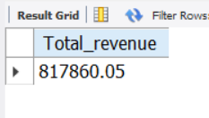

- Average Order Value: Calculate the average amount spent per order by dividing total revenue by the total number of orders.

select round(sum(total_price)/count(distinct order_id),2) as Avg_order_val from pizza_sales;

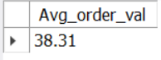

- Total Pizzas Sold:

select sum(quantity) as Total_pizza_sold from pizza_sales;

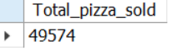
- Total Orders:
select count(distinct order_id) as Total_orders from pizza_sales;

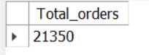
- Average Pizzas per Order: Calculate the average number of pizzas sold per order by dividing the total pizzas sold by the total number of orders.
select round(sum(quantity)/count(distinct order_id),2) as Avg_pizza_per_order from pizza_sales;

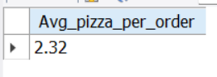

Chart Requirements
We need to visualize different aspects of the pizza sales data to identify trends, customer preferences, and product performance.
- weekday Trend for Total Orders:
select dayname(order_date), count(distinct order_id) as Total_orders from pizza_sales
group by 1 order by total_orders desc;

dayname(order_date) | Total_orders
Friday | 3538
Thursday | 3239
Saturday | 3158
Wednesday | 3024
Tuesday | 2973
Monday | 2794
Sunday | 2624

- Hourly Trend for Total Orders:
select hour(order_time) as hour_of_day, count(distinct order_id) as Total_orders from pizza_sales
group by 1 order by hour_of_day;

hour_of_day | Total_orders
9 | 1
10 | 8
11 | 1231
12 | 2520
13 | 2455
14 | 1472
15 | 1468
16 | 1920
17 | 2336
18 | 2399
19 | 2009
20 | 1642
21 | 1198
22 | 663
23 | 28

- Percentage of Sales by Pizza Category:

select pizza_category, round(sum(total_price),2) as Total_cate_sales
,round((sum(total_price)/(select sum(total_price) from pizza_sales)),2)*100 as
perc_of_total_sales from pizza_sales group by pizza_category order by Total_cate_sales desc;

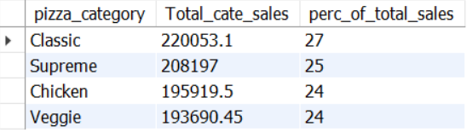
- Percentage of Sales by Pizza Size:
select pizza_size, round(sum(total_price),2) as Total_size_sales
,round((sum(total_price)/(select sum(total_price) from pizza_sales)),2)*100 as
perc_of_total_sales from pizza_sales group by pizza_size order by Total_size_sales desc;

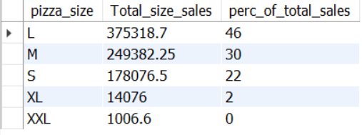

- Total Pizzas Sold by Pizza Category:
select pizza_category, sum(quantity) as Total_pizza_sold from pizza_sales
group by 1 order by Total_pizza_sold desc;

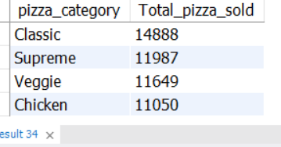

- Top 5 Best Sellers by Total Pizzas Sold:

select pizza_name, sum(quantity) as Total_pizza_sold from pizza_sales
group by 1 order by Total_pizza_sold desc limit 5;

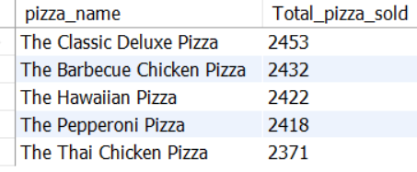

- Bottom 5 Worst Sellers by Total Pizzas Sold:

select pizza_name, sum(quantity) as Total_pizza_sold from pizza_sales
group by 1 order by Total_pizza_sold limit 5;

